Lateral Movement & Privilege Escalation Investigation

Executive Summary
This project simulates a post-compromise scenario in an Active Directory environment, focusing on how an attacker performs lateral movement and leverages authentication mechanisms to access additional systems within the network.
The investigation demonstrates how attackers expand their access by reusing credentials, abusing remote execution tools, and pivoting through compromised hosts to reach restricted services.

Scenario
After obtaining valid credentials within the domain, suspicious internal activity suggested that an attacker was attempting to move laterally across systems.
The objective was to:
- Identify lateral movement techniques used
- Understand authentication mechanisms involved
- Analyze how attackers pivot to access restricted systems

Investigation

1️-Lateral Movement Overview
Lateral movement refers to techniques used by attackers to move between systems after initial access.
Key objectives include:
- Expanding control within the network
- Accessing sensitive systems
- Bypassing network restrictions
- Maintaining persistence and avoiding detection
Observation:
Lateral movement is not a single step — it is a continuous cycle of movement, privilege escalation, and credential reuse.
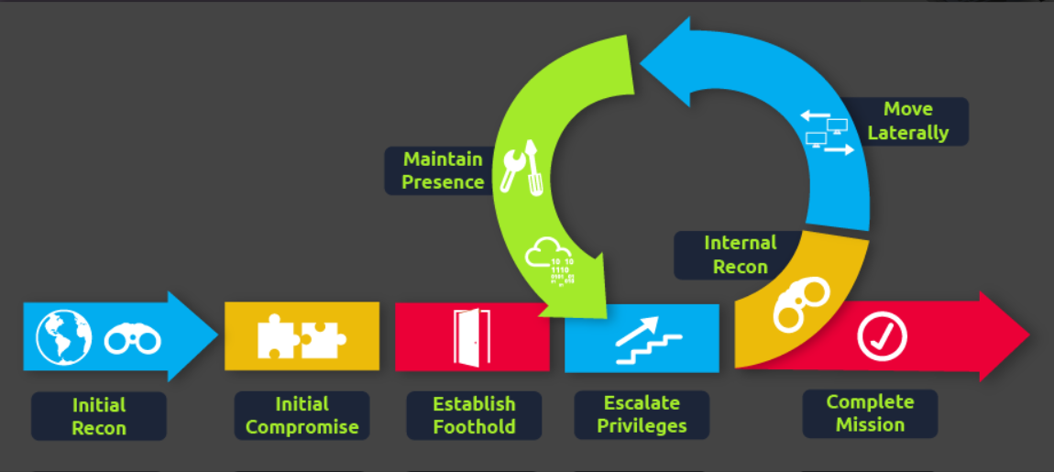

2️-Remote Execution via PsExec
One of the primary techniques identified was the use of PsExec for remote command execution.

🔹 How it works:
- Connects to target system via SMB (Port 445)
- Uploads a service binary (psexesvc.exe)
- Creates and runs a remote service
- Establishes communication via named pipes
Requirement:
Administrative privileges on the target machine
Impact:
Allows full remote command execution on another system
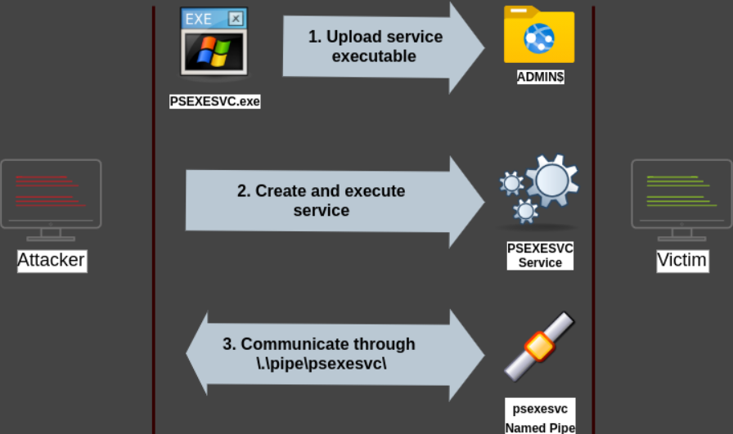

3️-Authentication Mechanisms in Movement

🔹 NTLM Authentication
- Uses challenge-response mechanism
- Commonly used during SMB-based communication
Risk:
Can be reused or relayed for authentication across systems
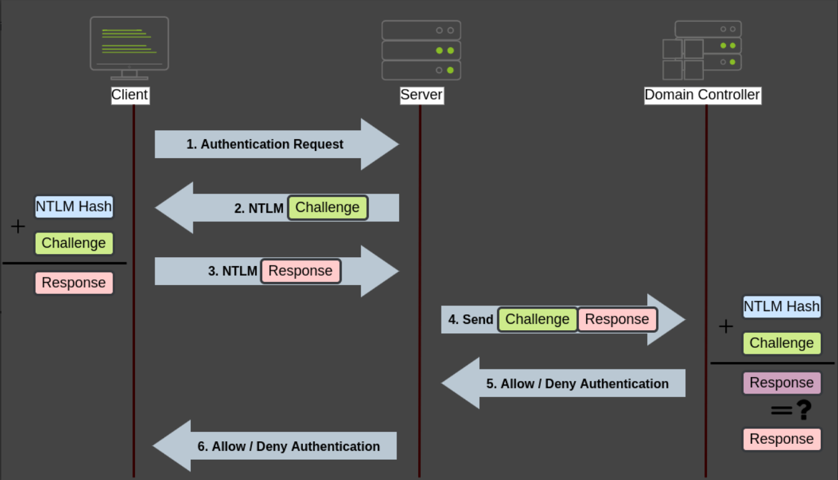

🔹 Kerberos Authentication
Kerberos is the primary authentication protocol in AD environments.

🔹 Process:
- User requests TGT (Ticket Granting Ticket)
- Receives Session Key + TGT
- Requests TGS (service ticket) using TGT
- Authenticates to service
Key Insight:
Credentials are not sent directly — tickets are used instead
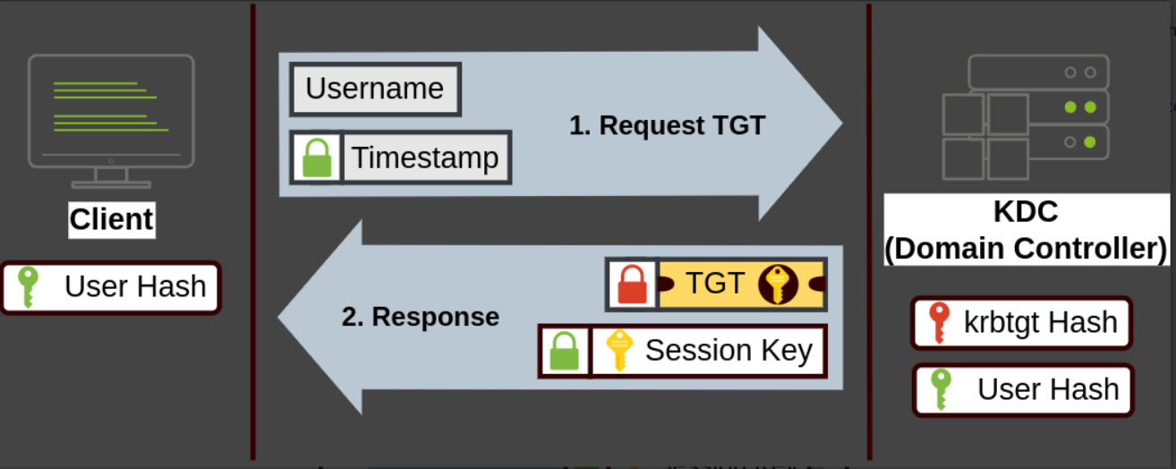
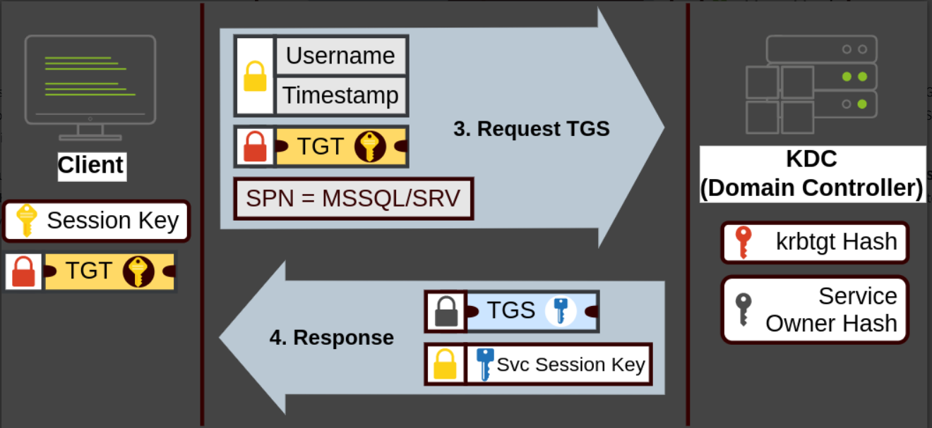

4️-Pivoting via SSH Tunneling
The investigation demonstrated how attackers pivot using compromised systems.

🔹 Scenario:
- Attacker cannot directly access target server
- Compromised host (PC-1) has access

🔹 Solution:
- Use SSH tunneling to forward traffic
- Create a tunnel from compromised host to attacker machine
- Access restricted services (e.g., RDP port 3389)
Result:
- Traffic appears to originate from internal host
- Bypasses network restrictions
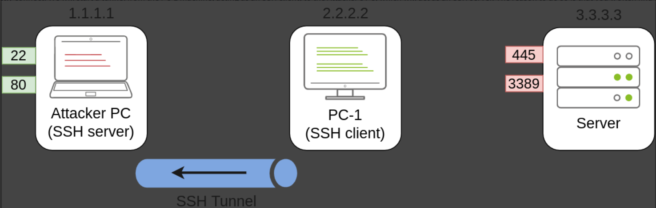
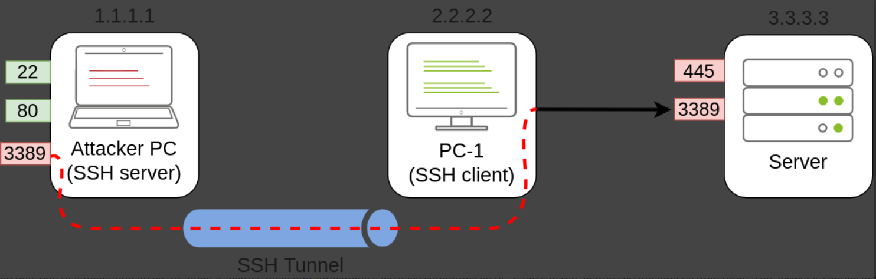

Findings
- Credential reuse enables movement across systems
- Administrative privileges significantly increase impact
- Authentication mechanisms (NTLM, Kerberos) can be abused
- Internal hosts can be used to bypass network restrictions

Assessment
The environment is vulnerable to lateral movement following initial compromise.
Once a single host is compromised, attackers can pivot, escalate, and expand access across the domain.

Severity: HIGH
- Enables access to multiple systems
- Facilitates privilege escalation
- Can lead to full domain compromise

SOC Analyst Actions

Immediate
- Isolate compromised hosts
- Reset affected credentials

Hardening
- Restrict administrative privileges
- Disable unnecessary remote services
- Enforce network segmentation

Monitoring
- Detect abnormal lateral connections (SMB, RDP, WinRM)
- Monitor PsExec usage
- Track authentication anomalies

Key Takeaways
- Lateral movement is a critical phase after initial access
- Internal network trust is a major security risk
- Authentication abuse enables attacker progression
- Monitoring internal activity is essential

